Mental Health First Aid
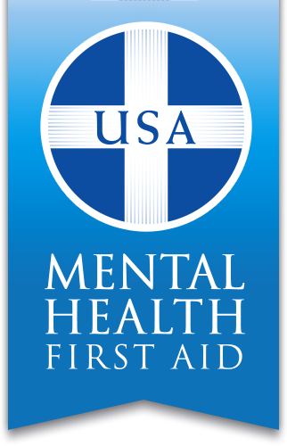

Mental Health First Aid Teaches You:
- Signs of addictions and mental illnesses
- 5-step action plan to assess a situation and help
- Impact of mental and substance use disorders
- Local resources and where to turn for help

Who Can Be a Mental Health First Aider?
- Caring Citizens
- Consumers and Family Members
- Members of Faith Communities
- Social Workers
- Substance Abuse Professionals
- Policymakers
- Mental Health Authorities
- Police/First Responders/Security Personnel
- Nurses/Physicians Assistants/Primary Care Workers
- Volunteers

Building Stronger Communities
The AbbeHealth Affiliates are excited to offer a Mental Health First Aid Training (MHFA) in your community.
The MHFA programs teach community members skills on identifying and responding to an adult who may be experiencing a mental health issue. This is comparable to learning first aid training for physical health, but instead will focus on mental health. This program has been developed by the National Council for Behavioral and further information can be found on their website at www.MentalHealthFirstAid.org.
Upon completion of the training you will receive a certificate and a manual. You must attend the entire training to receive a certificate.
When: December 5, 2018
Time: 8am-530pm
Full participation all day is required for certification
Where: Independence Public Library
805 1st St E, Independence, IA 50644

Lunch: Is not provided; day includes two 15 min and one 60 min break.

Cost: FREE as sponsored by the East
Central Region
To Register: Email tmineart@abbehealth.org by December 3, 2018.

Space is Limited-Register Today!

Abbe Inc. is an Approved Provider
Iowa Board of Social Work, Number 0096
Iowa Board of Behavioral Science Examiners, Number AS97-14
This program has been approved for 8 (nursing) contact hours through Abbe Center, IBON provider #304. Participants must attend the entire event to receive credit.

